**Unit 1 - Lesson 1**

**Functions and Inverse Functions**

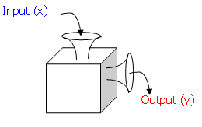

**Learning Targets:**

SWUT:

Functions are relations in which each item for the domain pairs with exactly one item from the range which can be verified by the Vertical Line Test or mapping.

Equations of functions can be written using **function notation, f(x)** in place of y.

An inverse of a function, $f^{-1}\left(x\right)$  is found when the domain (x) and range (y) of the function are switched.

The graphs of a relation and its inverse are the reflections of each other in the line y=x.

The range of the relation is the domain of the inverse and the domain of the relation is the range of the inverse.

**Domain and Range**

The ***domain*** is….

The ***range*** is….

Examples: State the domain and range of each of the following functions:

1. $\left\{\left(1, 2\right), \left(2, 3\right), \left(-3, 2\right), (0,5)\right\}$ Domain:

Range:

1. 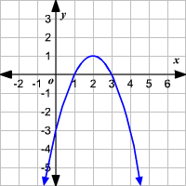 Domain:

Range:

1. 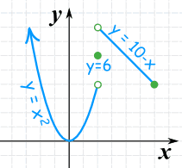 Domain:

Range:

**Functions**

A ***function*** is….. (x’s cannot repeat!)

***Function Notation*** is…..

***The Vertical Line Test*** is….

Sketch TWO relations that Sketch TWO relations that ARE functions are NOT functions.

**Inverse Functions**

***So, how do you find an inverse?***

**Inverse Function Notation**

**Function Notation**

A ***one-to-one function*** is…

Ex. 1: Graph the inverse of the following function: (reflection over y = x)

Now, state domain and range of both:

f(x): Domain Range

f-1(x): Domain Range

Notice anything?

Ex 2: Find the inverse of the function $f\left(x\right)=3x-4$

Ex 3: Given the function $g\left(x\right)=\sqrt{x-2}+5$. Find $g^{-1}(x)$.

Ex 4: Consider the function $j\left(x\right)=\frac{x+2}{x-5}$, find $j^{-1}(x)$.

HOMEWORK 1-1

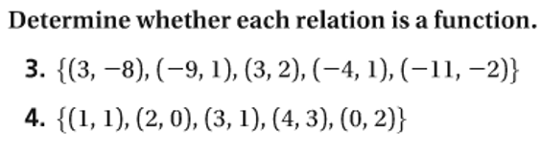

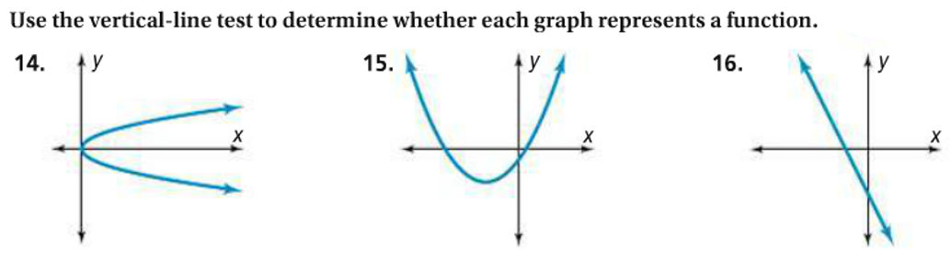

**ALGEBRA 1 REVIEW:**

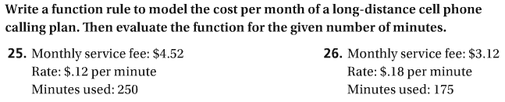

**Find the inverse of each, then state the domain and range for f(x) and f-1(x)**

 

**\*\*\*ALGEBRA 2 FINALS REVIEW QUESTIONS:\*\*\***

